**자료구조론 CC343_2207**

**Reading assignment 8**

**경기대학교 컴퓨터공학부**

**201511837 이상민**

**Review Questions**

1. What is a priority queue? Give its applications.  
우선 순위 대기열이란 무엇입니까? 응용 프로그램을 제공합니다.

A is different from a normal , because instead of being a “first-in-first-out”, values come out in order by priority. It is an abstract data type that captures the idea of a container whose elements have “priorities” attached to them. An element of highest priority always appears at the front of the queue. If that element is removed, the next highest priority element advances to the front.  
A priority queue is typically implemented using .

2. Explain the concept of a circular queue? How is it better than a linear queue?  
원형 줄의 개념을 설명하세요? 어떻게 선형 대기열보다 낫죠?

1. Memory Space: Linear queue drains the memory space while the circular queue makes the valuable and efficient use of space.
2. Linear queue follows first in first out order whereas the Circular queue doesn’t have any specific order.
3. The insertion and deletion of the elements are fixed in linear queue i.e, addition from the rear end and deletion from the front end. On the other hand, the circular queue is capable of inserting and deleting the element from any point or any side until it is abandoned or unoccupied.

3. Why do we use multiple queues?  
대기열을 여러 개 사용하는 이유는 무엇입니까?

1. Queue is useful in CPU scheduling, Disk Scheduling. When multiple processes require CPU at the same time, various CPU scheduling algorithms are used which are implemented using Queue data structure.
2. When data is transferred asynchronously between two processes.Queue is used for synchronization. Examples : IO Buffers, pipes, file IO, etc.
3. In print spooling, documents are loaded into a buffer and then the printer pulls them off the buffer at its own rate. Spooling also lets you place a number of print jobs on a queue instead of waiting for each one to finish before specifying the next one.
4. Breadth First search in a Graph .It is an algorithm for traversing or searching graph data structures. It starts at some arbitrary node of a graph and explores the neighbor nodes first, before moving to the next level neighbors.This Algorithm uses Queue data structure.
5. Handling of interrupts in real-time systems. The interrupts are handled in the same order as they arrive, First come first served.
6. In real life, Call Center phone systems will use Queues, to hold people calling them in an order, until a service representative is free.

4. Draw the queue structure in each case when the following operations are performed on an empty queue.  
빈 대기열에서 다음 작업을 수행할 때 각 경우에 대기열 구조를 그립니다.

(a) Add A, B, C, D, E, F

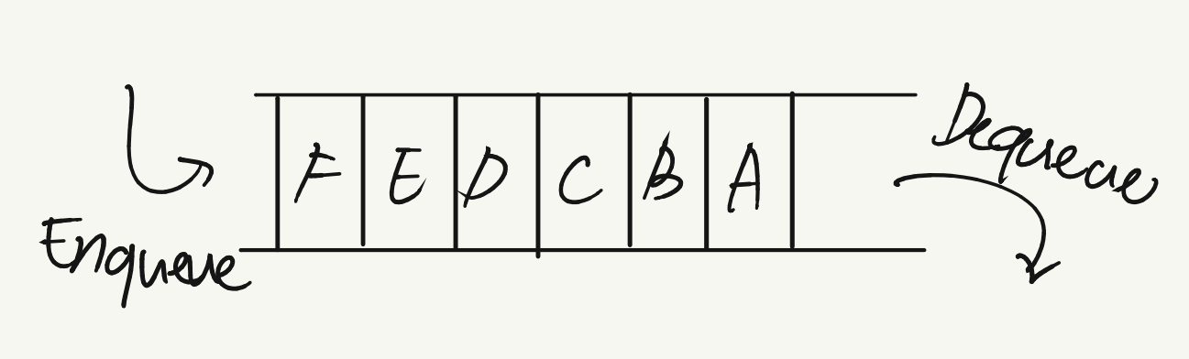

(b) Delete two letters

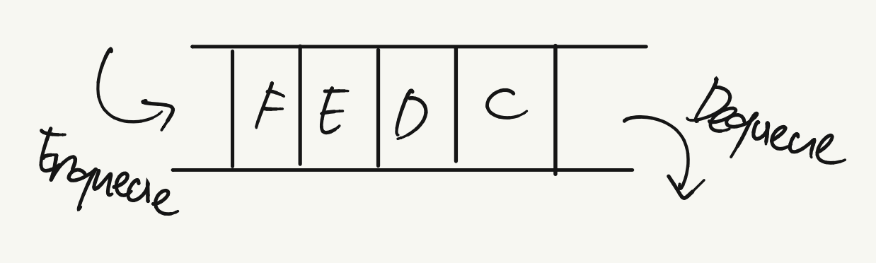

(c) Add G

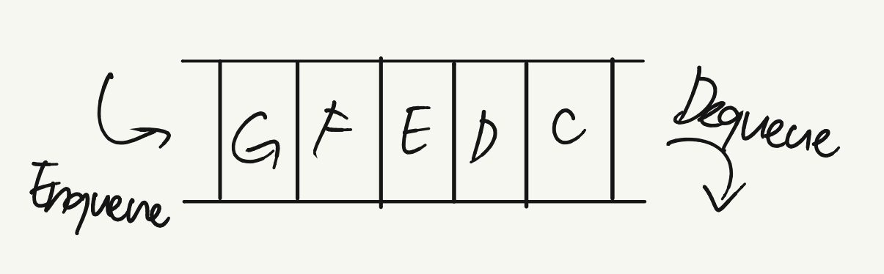

(d) Add H

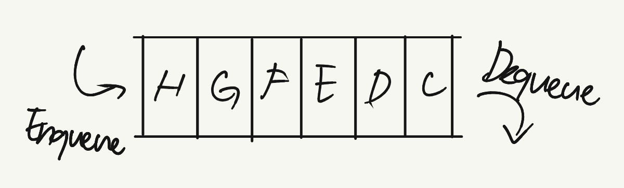

(e) Delete four letters

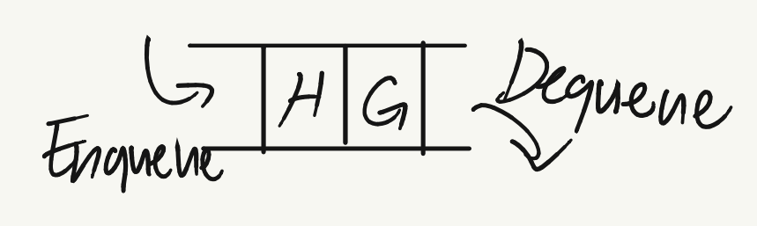

(f) Add I

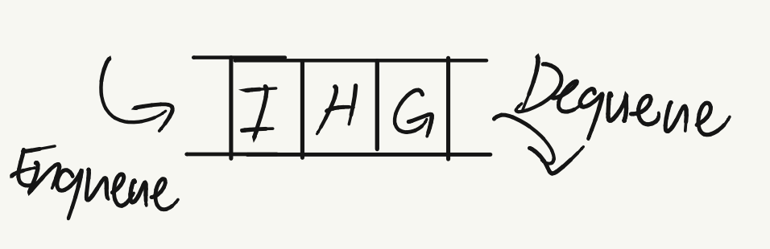

5. Consider the queue given below which has FRONT = 1 and REAR = 5.



Now perform the following operations on the queue:

1. Add F

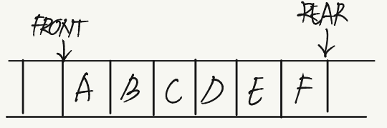

1. Delete two letters

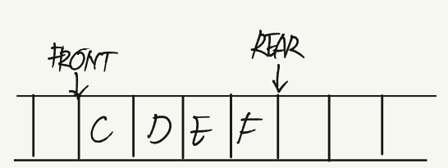

1. Add G

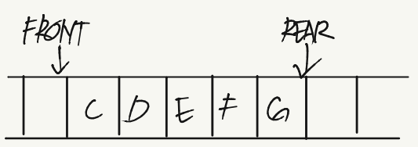

1. Add H

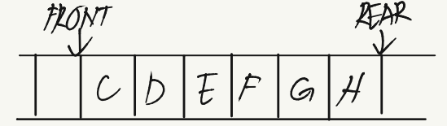

1. Delete four letters

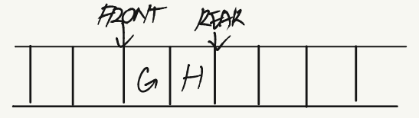

1. Add I

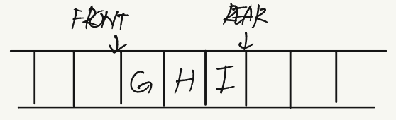

6. Consider the dequeue given below which has LEFT = 1 and RIGHT = 5.



Now perform the following operations on the queue:

1. Add F on the left

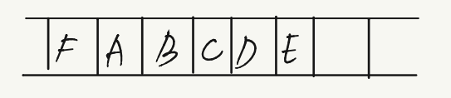

1. Add G on the right

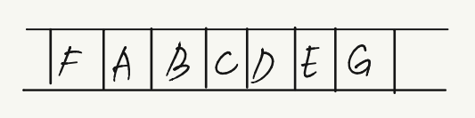

1. Add H on the right

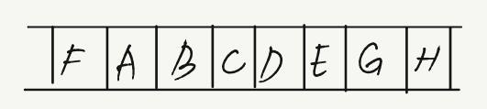

1. Delete two letters from left

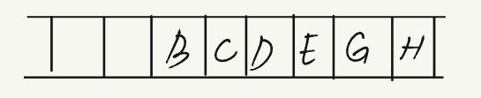

1. Add I on the right

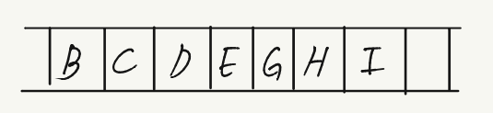

1. Add J on the left

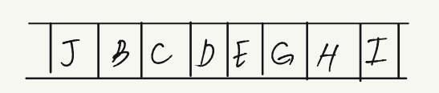

1. Delete two letters from right

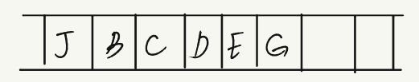

**Multiple-choice Questions**

1. A line in a grocery store represents a

(a) Stack

**(b) Queue**

(c) Linked List

(d) Array

2. In a queue, insertion is done at

**(a) Rear**

(b) dequeue

(c) Back

(d) Top

3. The function that deletes values from a queue is called

(a) enqueue

**(b) dequeue**

(c) pop

(d) peek

4. Typical time requirement for operations on queues is

**(a) O(1)**

(b) O(n)

(c) O(logn)

(d) O(n^2)

5. The circular queue will be full only when

(a) FRONT = MAX –1 and REAR = Max –1

**(b) FRONT = 0 and REAR = Max –1**

(c) FRONT = MAX –1 and REAR = 0

(d) FRONT = 0 and REAR = 0

**True or False**

1. A queue stores elements in a manner such that the first element is at the beginning of the list and the last element is at the end of the list. **: False**

2. Elements in a priority queue are processed sequentially. **: False**

3. In a linked queue, a maximum of 100 elements can be added. **: False**

4. Conceptually a linked queue is same as that of a linear queue. **: True**

5. The size of a linked queue cannot change during run time. **: False**

6. In a priority queue, two elements with the same priority are processed on a FCFS basis. **: True**

7. Output-restricted deque allows deletions to be done only at one end of the dequeue, while insertions can be done at both the ends. **: True**

8. If FRONT=MAX – 1 and REAR= 0, then the circular queue is full. **: True**

**Fill in the blanks**

1. New nodes are added at ______ of the queue.   
**answer : Rear**

2. ______ allows insertion of elements at either ends but not in the middle.   
**answer : Dequeue**

3. The typical time requirement for operations in a linked queue is ______.   
**answer : O(1)**

4. In ______, insertions can be done only at one end, while deletions can be done from both the ends.   
**answer : Input restricted dequeue**

5. Dequeue is implemented using ______.   
**answer : Circular array or a circular doubly linked list**

6. ______ are appropriate data structures to process batch computer programs submitted to the computer centre.   
**answer : Priority queue**

7. ______ are appropriate data structures to process a list of employees having a contract for a seniority system for hiring and firing.  
**answer : Queues**